**Chapter 9: Small Bodies of the Solar System**

**9.1: Dwarf Planets May Outnumber Planets**

**Dwarf Planets**

* Dwarf planets are planets that have failed to clear the area around their orbit
  + Pluto
  + Eris
  + Haumea
  + Makemake
  + Ceres (Only one not beyond Pluto)
* Pluto
  + Moon Charon
  + Tidally locked with moon
  + Orbit is 248 Earth Years
* Eris
  + Farthest known object from sun (97.6 AUs)
  + About the same size as Pluto, but with more mass
* Haumea and Makemake
  + Both farther out than pluto, both have moons, Haumea spins really fast
* 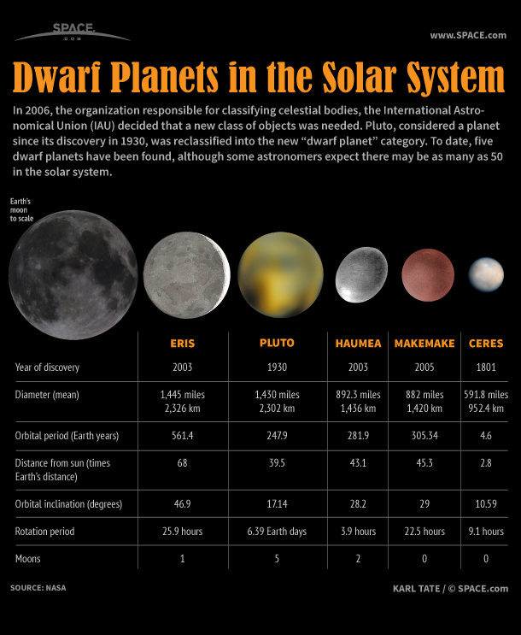Ceres
  + Contains about 1/3rd the total mass in the asteroid belt
  + Contains the first detection of water in the asteroid belt

**9.2: Moons as Small Worlds**

**Geologically Active Moons**

* Io
  + Highly volcanically active due to close encounter with Jupiter
    - Causes craters to be covered up
  + Abundant in sulfur (causes color)
* Enceladus
  + Cryobolcanism
    - Volcanism driven by low temperature volatiles (nitrogen/water)
    - Ejects ice into Saturn’s E-ring
* Triton
  + Cryovolcanism
  + Triton is relatively young (few craters), thin atmosphere, icy methane surface
  + Ice driven greenhouse effect present

**Possibly Active Moons**